Supplemental Discussion
Issues with data and modelling approaches

- Inequitable distribution of data
Time biased toward regions with adequate monitoring efforts¹. The distribution of assessed small pelagic fishes in the RAM Legacy stock assessment database highlights this inequity. Most countries in Central America and South America, eastern Africa, and Asia have less than 5% of their stocks assessed in the database, while the countries in these regions with more than 5% of their small pelagic stocks assessed have above 80% inclusion within the database¹. Nearly every nation in North America, Europe, and western Africa have the majority of their small pelagic fishes assessed¹. Low commercial importance and the lack of age and/or length data are the main reasons why many exploited stocks remain unassessed^{1–5}. Data from fisheries-dependent sources lack the true underlying error distribution and sample variances, making it difficult to use data weighting methods to compare across datasets⁶.
Since abundance at a large scale (i.e. global, this study) is equivalent to the mathematical weighted average abundance at smaller scales, the inequitable distribution of data limits the conclusions able to be made. Data on marine biodiversity are further biased by spatial patterns in species richness, with latitude^{7,8}, longitude⁹, and depth¹⁰ showing gradients in diversity; however, there is contention as to whether these patterns are representative enough to be universally accepted and whether diversity is driven by these variables or if they are functions of other drivers¹¹. Empirical reports of biodiversity show different trends based on the report type: reviews, global indicators, and meta-analyses generally highlight declines in biodiversity, while long-term databases show mixed trends in biodiversity¹². Most metrics fail to differentiate between native and non-native taxa when calculating biodiversity, which can skew estimates to appear more positive than reality¹³.
;in contrast, that do haveMany stocks reamin unassessed due to low commercial important or the lack of age or lengthwhich makes
Because. H;whereas
- Combining different survey methodologies
Many survey methods for assessing animal abundance come with assumptions that may lead to biases in the point estimates. For instance, abundance estimates for cetaceans are often negatively biased because they make simplifying assumptions about animal behavior. For instance, line-transect surveys can produce a negative bias by assuming that the probability of seeing an animal on the trackl ine is 100% (g(0) = 1; Buckland et al. 2001), which even for large animals with highly visible blows is likely an overestimate because cetaceans exist in a 3-D environment and could be below the surface. In addition, mark-recapture estimates often assume that all individuals in the study area are equally available to be captured, however, especially when survey areas do not cover the entire range of the population, this can lead to negative biases when there are some animals that are more resident to the study area than others (Pollock 2000). This can be a problem for wide-ranging cetaceans when study areas can be much smaller than the full range of the species (e.g., Olson et al 2025).However, the extent of these negative biases are difficult to quantify. By combining estimates across survey methodologies these biases may lead to the detection of trends where there are none. For instance, if line transect surveys are used in early years, and then mark recapture estimates are used in later years and the mark recapture estimates are more negatively biased than the line-transect surveys, this could lead to the detection of a negative trend even if the population itself had remained stable. Some of this was accounted for in the model by allowing for differences in observation error between time series, but this would not fully account for potentially biased point estimates. Since there are many survey methodologies within a single taxonomic group in our study, these effects are likely to be minimal, but they would likely result in an underestimation of uncertainty in our model results.

Threats
Habitat loss
The loss of foundation species (e.g., mangroves, corals, kelp, etc.,) that contribute to the structure of an ecosystem may be particularly detrimental, since it may also meanhabitat loss for other species in that community^{14,15}. Foundation species can serve as refuge from predators^{16,17} and rough conditions¹⁶, nurseries for juvenile fish^{16,17}, substrate for settlement¹⁷, and prey or hunting opportunities^{16,17}.

Introduction of Invasive Species
Although the direct impact of invasive species on many taxa is not recorded directly in the literature, there are multiple examples of the negative impacts of invasive species on marine ecosystems. Two species of invasive algae (Caulerpa taxifola and C. refuges awayorsubstratesfeeding grouinds

racemosa) have overcrowded native algae in the Mediterranean¹⁸, lionfish (Pterois spp.) in the northwest Atlantic outcompete native fish for prey and lack a natural predator in the region¹⁹, and crown-of-thorns starfish (Acanthaster spp.) quickly graze through corals on reefs, degrading habitat and removing the corals from the ecosystem²⁰. Ballast water from ships is the primary vector of introduction; in 1998 alone, San Francisco Bay saw over 230 unique species introduced into its waters²¹. in this way Other pathways for introduction include aquaculture, aquarium, and live seafood releases as well as the construction of canals and other connections between bodies of water²².

Urbanization and Land Use Change
Urbanization and land-use change can pose a significant threat to marine biodiversity. They are not simply changes in the appearance of coastal environments; they can degrade habitats, alter species distributions, disrupt biological processes, and reduce the resilience of marine populations (Graells et al. 2022; Rosenberg et al. 2022). The expansion of cities, ports, infrastructure, and other human developments can modify shoreline habitats and change the physical and ecological conditions that marine species depend on. Although some species may tolerate or make use of urbanized habitats, species with more specific habitat requirements may be more vulnerable to displacement (McIlroy et al. 2024; Lowe & Peterson 2014). In addition, changes associated with urban development may reduce the genetic diversity and resilience of marine populations (AlterTBD lmk if you need et al. 2021; Karachaliou et al. 2025). Overall, these effects can alter the composition of coastal communities and contribute to declines in marine biodiversity.

Pollution
The constant deposition of anthropogenic pollutants into the ocean is a pervasive threat to global biodiversity. Widespread accumulation of macro- and microplastics, chemical contaminants, and nutrient loading are among the most notable forms of marine pollution.
An estimated 4.8 to 12.7 million metric tons of plastic are deposited in the ocean each year²³. Macroplastics often represent immediate physical hazards to marine fauna via entanglement and smothering. Sub-lethal effects may include physical injuries, malnutrition, gastrointestinal damage, and physiological stress²⁴. Macroplastic pollution has also been associated with the loss of structural complexity and associated biodiversity in benthic habitats²⁵. Micro and nanoplastics, now considered virtually ubiquitous in the oceans, are readily ingested by a vast array of different taxa, including zooplankton, filter feeders, and benthic detritivores^{26,27}. Negative effects of microplastic ingestion include low nutritional condition, behavioral changes, and toxicity^{28,29}. Risks of microplastic ingestion vary according to the taxa’s habitat and feeding strategy²⁷.
The widespread use of industrial-grade, artificial agricultural fertilizers coupled with inappropriate treatment and disposal procedures has been linked to excessive nutrient loading in coastal zones, fueling microalgal blooms that can severely deplete the dissolved oxygen and cause mass mortality events^{30,31}. Globally, over 400 dead zones have been confirmed as a result of excessive nutrient runoff into the sea³². Other types of chemical pollution include the inappropriate disposal of pharmaceuticals, heavy metals, and industrial runoff that disrupts physiological processes³³. Aquaculture continues to grow as an alternative to wild fisheries for providing marine protein³⁴. However, improper implementation can cause disease outbreaks in natural populations, spike organic pollution in the surrounding habitat, cause genetic mixing of wild and farmed stocks, and can lead to overfishing of wild stocks used for feed in these operations³⁵.
Noise disruptions alter the soundscape³⁶. Oil exploration and mining is a rapidly expanding field, but these activities impact whales³⁶, elasmobranchs³⁷, and countless other taxa. Marine energy from tides and wind farms have been a growing industry and may have increased deleterious effects on marine taxa³⁸. Low-frequency noise and electromagnetic radiation from marine energy sources can hinder the recovery of marine species³⁹.

which fuelmeanspresence of which all canbut is certainly not without risks. I
Not to be overlooked, noisepollution alterscetaceans

Climate Change
The shift in lower-trophic biomass between species impacts predators at higher trophic levels in the ecosystem^{40,41}. The collapse of a population shifting trophic dynamics, known as prey switching, has been seen across the global oceans^{42–44}.
Rising ocean temperatures impact every stage of a species’ life cycle⁴⁵ and can drastically restructure community and ecosystem structure⁴⁶. Species range expansions occur at faster rates toward the poles than contractions near the equator⁴⁷, but studies suggest that temperature may not be the limiting factor for range expansion in many species⁴⁸. Warming may also push species beyond tolerance thresholds and drive ecosystem shifts^{49–52}.
Changes in ocean circulation⁵³ can limit movement of species to more suitable habitat as currents can serve as a biogeographical barrier for movement^{54,55}. Shifting stratification of ocean layers can restrict horizontal movements and serve as barriers for migration⁵³.

life cycleWhen range shifting is not possible, warming

Exploitation
The largest directanthropogenic threat faced by marine biodiversity is exploitation^{56,57}. Marine species have historically been exploited either as a food resource or to produce commercially valuable products⁵⁸. While small-scale and subsistence fisheries for food have operated for millennia, many fisheries underwent rapid expansion during the latter half of the 20th century⁵⁹ ⁶⁰.Technological advancement in areas such as navigation^{61,62}, echolocation⁶³ and nylon fishing gear⁶⁴ led to more efficient targeting of fish stocks, in turn leading to the decline of many commercially valuable fish populations^{65,66}. Beyond food, demand for commercially valuable products also drove the substantial depletion and, in some cases extirpation, of marine mammals including pinnipeds^{67,68}, sea otters^{69,70} and cetaceans^{71,72}.These declines due to exploitation have led to the adoption of sustainability as a primary objective in fisheries management^{65,73}. However, sustainable management requires both assessment and management capacity, and is therefore often limited to countries with developed economies^{63,74,75}. While sustainable management has been effective in stabilizing population declines^{74,75}, the issue is further complicated due to the occurrence of illegal, unreported and unregulated (IUU) fishing^{65,76} , as removals in this context are difficult to account for^{77,78}.
Life history traits determine the intrinsic resiliency of a species to fishing. In general, higher trophic level species such as large predatory fish with slower growth rates, late onset of sexual maturation, low fecundity, and therefore higher energetic cost per egg are the most vulnerable to fishing, as these traits often imply lower population growth rates⁷⁹. Elasmobranchs are suitable examples of taxa that are highly sensitive to fishing, with severe declines of nearly two thirds their original abundance leading to highly depleted populations observed worldwide across many different species even with moderate levels of fishing pressure^{80–82}. Even with immediate halts on elasmobranch fishing, many populations would take several decades to recover to healthy levels due to high generation times. Despite lower vulnerability, small pelagic fish have also been impacted by unregulated fishing pressure across the world, with historically heavily exploited areas such as the Mediterranean among the most impacted¹. Many small-scale fisheries have a higher reliance on exploited or threatened species as well⁸³. At the global scale, recent decreases in fishing pressure has resulted in noticeable recoveries for both tuna^{84,85} and groundfish⁸⁶ at global scales. Historical fishing pressure for North Atlantic fishes has been twice as high as proposed F_{MSY}⁸⁷.
Fishing is an inherently non-random process; fishers disproportionately target the largest, more commercially desirable individuals within a stock. Selective harvest pressures like these have historically caused Fisheries-Induced Evolution (FIE): by unevenly removing larger, highly fecund individuals consistently, fishing effectively selects against individuals with faster growth rates, later maturation, and larger sizes, shifting the population towards smaller, slower-growing individuals with smaller reproductive output⁸⁸. FIE has been linked to causing unstable trophic structures^{89–93} and truncating the upper third of the marine size spectrum^{94,95}. As highly-fecund individuals massively contribute to the population’s reproductive rates, depleting the upper end of the marine size spectrum can cause deleterious effects such as decreased genetic diversity and recruitment failures, as the few spawning individuals remaining struggle to compensate for the high mortality common during early life stages ^{51,52}. The size of the catch is also highly correlated with fisheries profit, particularly in the Northern Hemisphere⁹⁶. Balanced harvesting, where fishing pressure is spread more evenly across age and size classes, has been shown to help limit trophic instability in highly fished ecosystems⁹¹, but issues with balanced harvesting, including the price of gear modifications to lower prices at market⁹², are difficult to overcome.
When the most desirable species within a fishery is a high trophic level predator that eventually becomes depleted, lower trophic levels can become serially depleted as the fishery moves to more abundant taxa, a phenomenon known as ‘fishing down the food web⁹⁷. Fishing down the food web can be deleterious for ecosystems, as the serial depletion of high trophic levels can severely disrupt trophic cascades and affect ecosystem stability^{98–100}. While dangerous for ecosystem structure, the prevalence of fishing down the food web has been historically overstated. Rather than being driven by upper trophic levels, fisheries often simply tend to pursue the highest possible return for the effort ¹⁰¹. In some systems, the loss of higher-trophic level species may cause temporary increases in abundance of lower-trophic level species in a phenomenon known as the predator release hypothesis^{102,103}. Climate change is anticipated to exacerbate the trophic restructuring and loss of yield in fisheries^{104–106}. Vessel strikes impact whales³⁶, elasmobranchs¹⁰⁷, and many other marine megafauna. Entanglement has been found in whales³⁶ and sharks¹⁰⁸.

The Existence of Losers Implies the Existence of Winners
As marine ecosystems have continued to be altered, winners have also emerged. Small pelagic fish have been estimated to be twice as abundant compared to pre-industrial fishing levels due to depletion of their predators, known as the predator release hypothesis¹⁰⁹. Small pelagics tend to have higher relative natural mortality compared to fishing mortality, which causes them to be less sensitive to changes in fishing effort compared to other taxa¹¹⁰. Although individual stocks show variability, small pelagics as a whole have not seen drastic shifts in their abundance since 1970, regardless of fishing pressure¹; this is contrary to trends for groundfish¹¹¹ and tuna^{112,113}, which have seen increases in abundance with decreasing fishing pressure over the past quarter century. Many invertebrates^{114–116} and mid-trophic predators¹¹⁷ have also seen their abundances increase with the initial defaunation associated with fishing, but many have seen this growth reversed with the growth of invertebrate fisheries globally and a shift to lower-trophic species within fisheries⁹⁷. Sponges are also likely to emerge as winners, with responses to the combined effects of ocean acidification and warming being less pronounced than other benthic taxa¹¹⁸.

Supplemental Results

Plankton
No time series data was available for use in this analysis, but studies exist that highlight global and regional trends in plankton abundance. The NASA global ocean color record was used to examine global changes in chlorophyll abundance as a proxy for phytoplankton abundance, finding no significant change in mean annual abundance between 1998 and 2015¹¹⁹. However, these results contrast with an analysis of the same data from 1998 to 2012, which found a statistically significant decline in chlorophyll abundance¹²⁰. A hindcast simulation of a climate system model found similar global declines in phytoplankton abundance¹²¹. Other analyses of satellite data show increasing phytoplankton abundance across a similar time range to the aforementioned studies^{122,123}.
Regional shifts in composition do exist; in the North and Equatorial Indian Ocean basins, a sharp decrease in chlorophyll abundance occurs, signaling a shift from large or intermediate-sized phytoplankton (e.g., diatoms) to smaller phytoplankton (e.g. cyanobacteria)¹¹⁹. Other study found increases of up to 4.7% in phytoplankton abundance between 1998-2007 using satellite-derived chlorophyll concentrations¹²³. For zooplankton, the only global estimate comes from simulation hindcasts, suggesting a 5% decline in biomass between 1960 and 2006¹²¹. Regionally, zooplankton biomass exhibit different trends in abundance across time^{124,125}.
,. These advances subsequentlyled
Generally,laterlower,are coupled withfishesrely more heavilyRecent
andBecauseof this group spawning individualscaught individuals.Theand associated with balanced harvesting can be
remaining web’This phenomenon alsoFishingis dangerous for ecosystem structure, it also due to

fishesarerelativeleading.This trendincreased in abundance

Planktons
some studies
has occurredAnother study
As opposed to the other groups modelled here, where anthropogenic impacts play a larger direct role, plankton abundance trends are largely driven by regional climate variability, such as trends in sea surface temperature, stratification, and circulation dynamics that operate differently across ocean basins. The ENSO, for example, is a major driver of interannual plankton biomass trends in the Gulf of Mexico, with El Niño and La Niña producing driving distinct cycles in abiotic conditions and coastal circulation that affect plankton biomass ¹²⁶. Similarly, the 2010-2011 El Niño to La Niña transition drove notable shifts in plankton community composition in Australia¹²⁷. The regional dependence of plankton communities on regional climate patterns partially explains why global syntheses of interannual trends in plankton abundance often disagree, while basin-specific analyses are more consistent. Phyto- and zooplankton are extremely diverse groups composed of taxa that are affected differently by environmental variability, so we would expect broad but heterogeneous impacts of climate change on these groups rather than uniformly effects on biomass. For example, warming surface waters that intensify ocean stratification and reduce nutrient load from upwelling will favor smaller, low-nutrient adapted phytoplankton such as picophytoplankton over large diatoms as the primary producer base¹²⁸.

Tables and Figures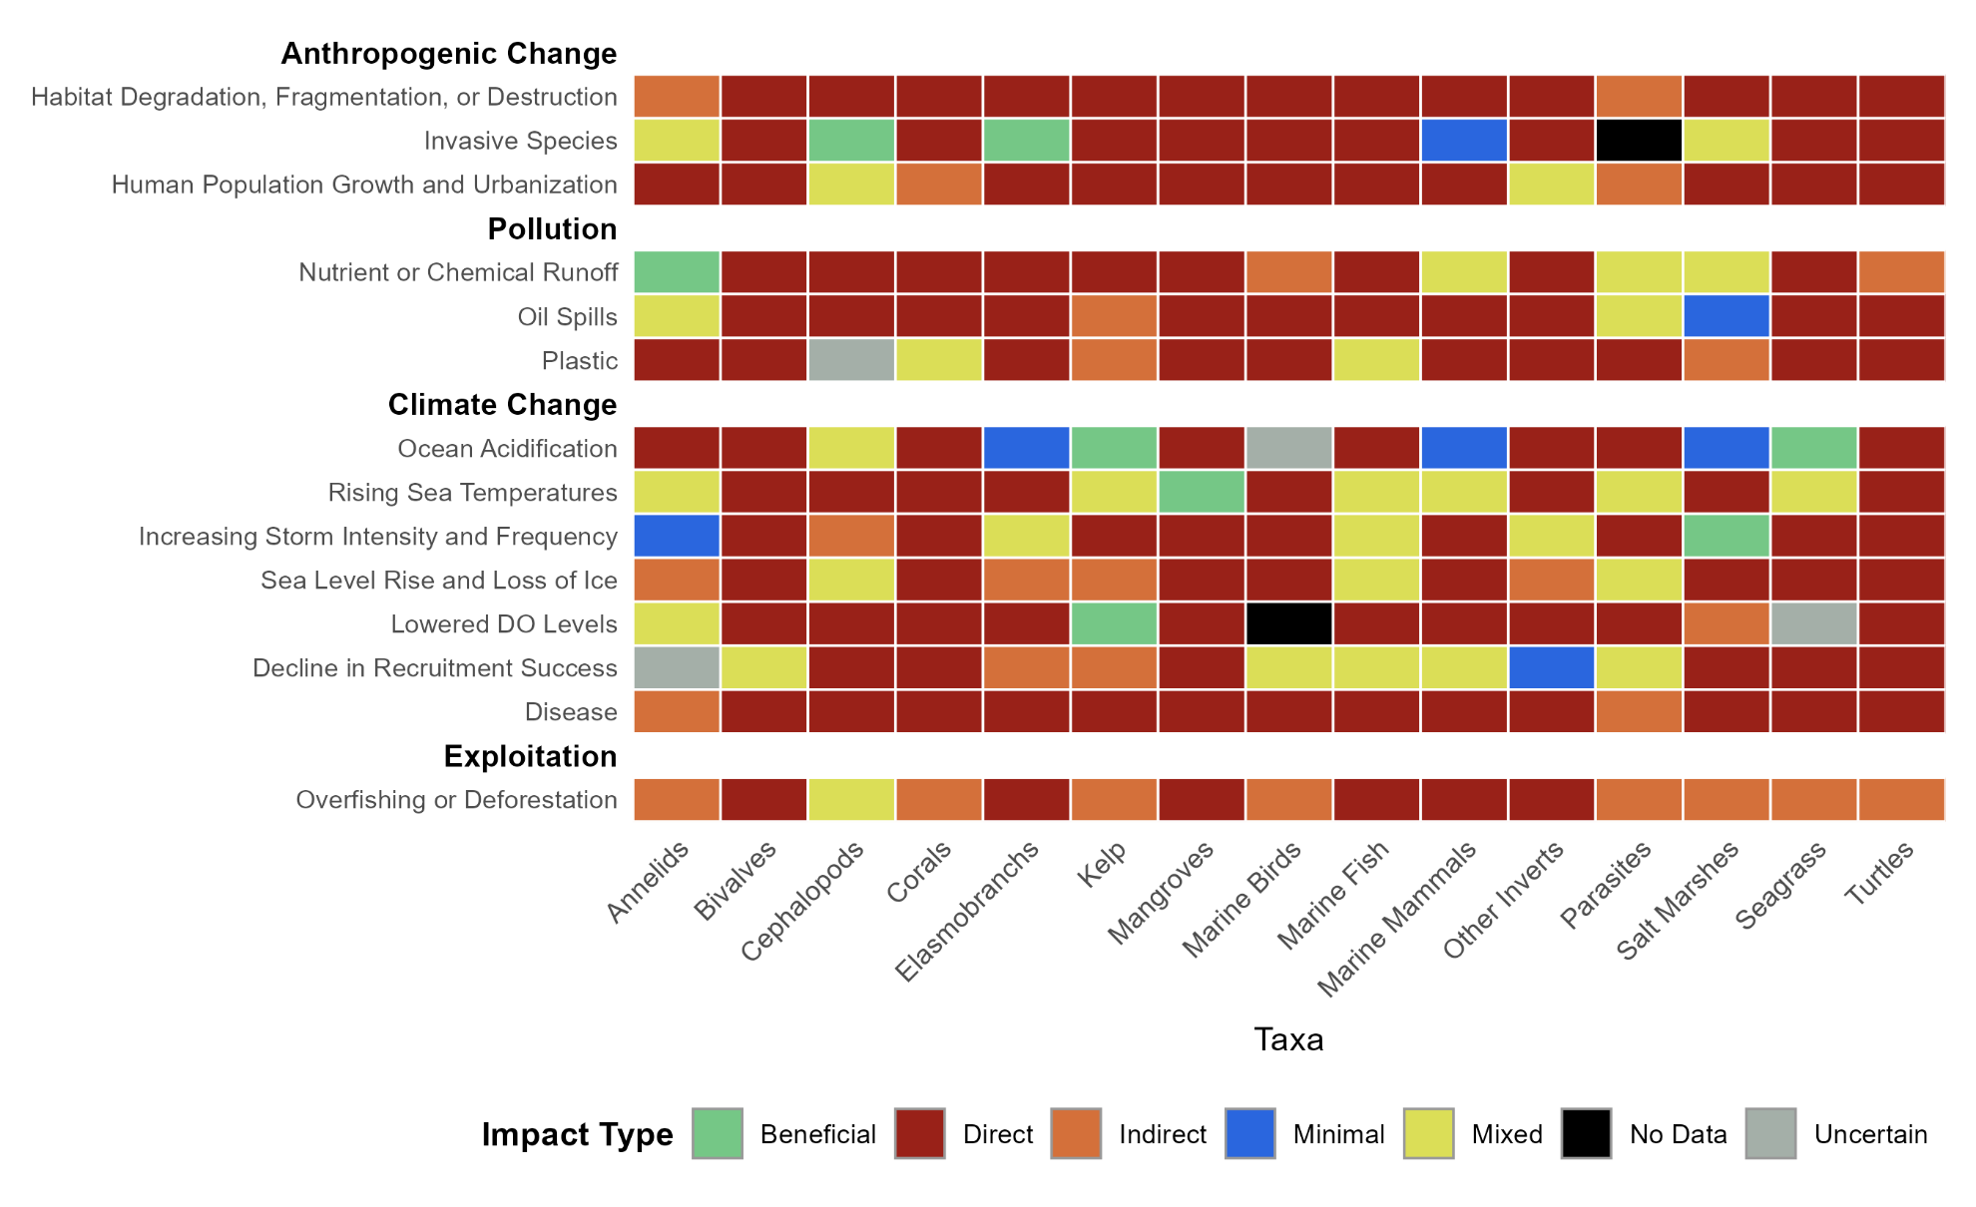

Table S1b: Threats to major marine habitats and taxa and whether the threat has a direct, indirect, minimal, or mixed impact on the taxa or habitat. *Indirect impacts for Disease suggest that the taxa are primarily hosts and/or transmitters of a disease rather than indirectly impacted by them

Index | Observation error (υ_{i}) | Process error (ω_{t})
1 | υ_{j,t} ~ N(0, σ^{obs}) | σ^{obs} ~ Exponential(1) | ω_{j,t} ~ N(0, σ^{process}) | σ^{process} ~ Exponential(1)
2 | υ_{j,t} ~ N(0, σ^{obs}) | σ^{obs} ~Half-normal(0,1) | ω_{j,t} ~ N(0, σ^{process}) | σ^{process} ~ Exponential(1)
3 | υ_{j,t} ~ N(0, σ^{obs}) | σ^{obs} ~Half-cauchy(0,1) | ω_{j,t} ~ N(0, σ^{process}) | σ^{process} ~ Exponential(1)
4 | υ_{j,t} ~ N(0, σ^{obs}) | σ^{obs} ~Exponential(1) | ω_{j,t} ~ N(0, σ^{process}) | σ^{process} ~ Half-normal(0,1)
5 | υ_{j,t} ~ N(0, σ^{obs}) | σ^{obs} ~Half-normal(0,1) | ω_{j,t} ~ N(0, σ^{process}) | σ^{process} ~ Half-normal(0,1)
6 | υ_{j,t} ~ N(0, σ^{obs}) | σ^{obs} ~ Half-cauchy(0,1) | ω_{j,t} ~ N(0, σ^{process}) | σ^{process} ~ Half-normal(0,1)
7 | υ_{j,t} ~ N(0, σ^{obs}) | σ^{obs} ~Exponential(1) | ω_{j,t} ~ N(0, σ^{process}) | σ^{process} ~ Half-cauchy(0,1)
8 | υ_{j,t} ~ N(0, σ^{obs}) | σ^{obs} ~Half-normal(0,1) | ω_{j,t} ~ N(0, σ^{process}) | σ^{process} ~ Half-cauchy(0,1)
9 | υ_{j,t} ~ N(0, σ^{obs}) | σ^{obs} ~Half-cauchy(0,1) | ω_{j,t} ~ N(0, σ^{process}) | σ^{process} ~ Half-cauchy(0,1)

Table S.2. Prior configuration grid for the prior sensitivity analyses

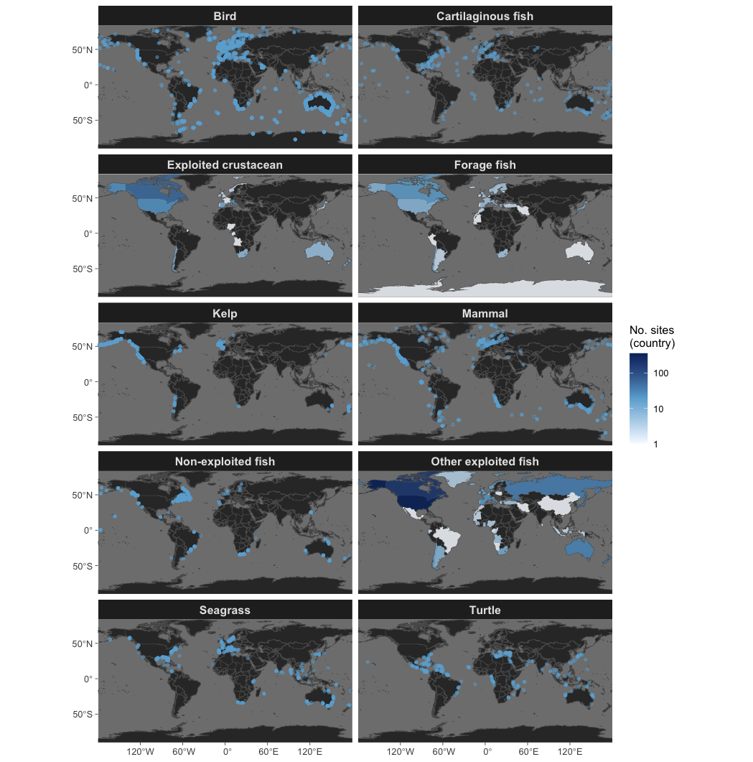

Figure S1. Global distribution of sites with time series (points) by major taxon. For taxon without specific coordinates, the total number of unique time series are reported by country.
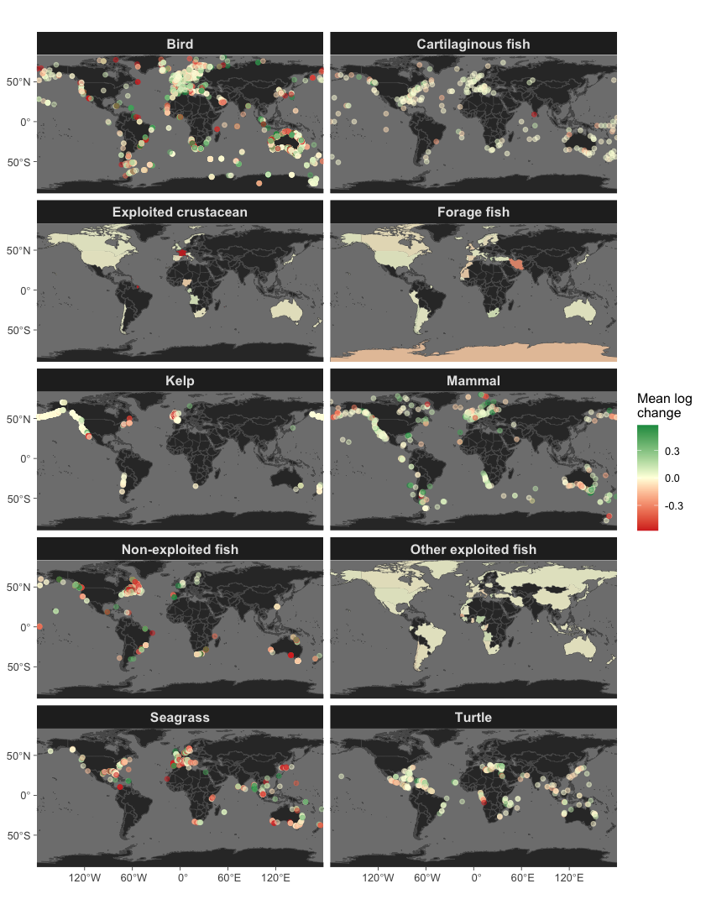

Figure S2. Global distribution of average rate of change for each population (points) by major taxon. For taxon without specific coordinates, the mean average rate of change is summarized by country.

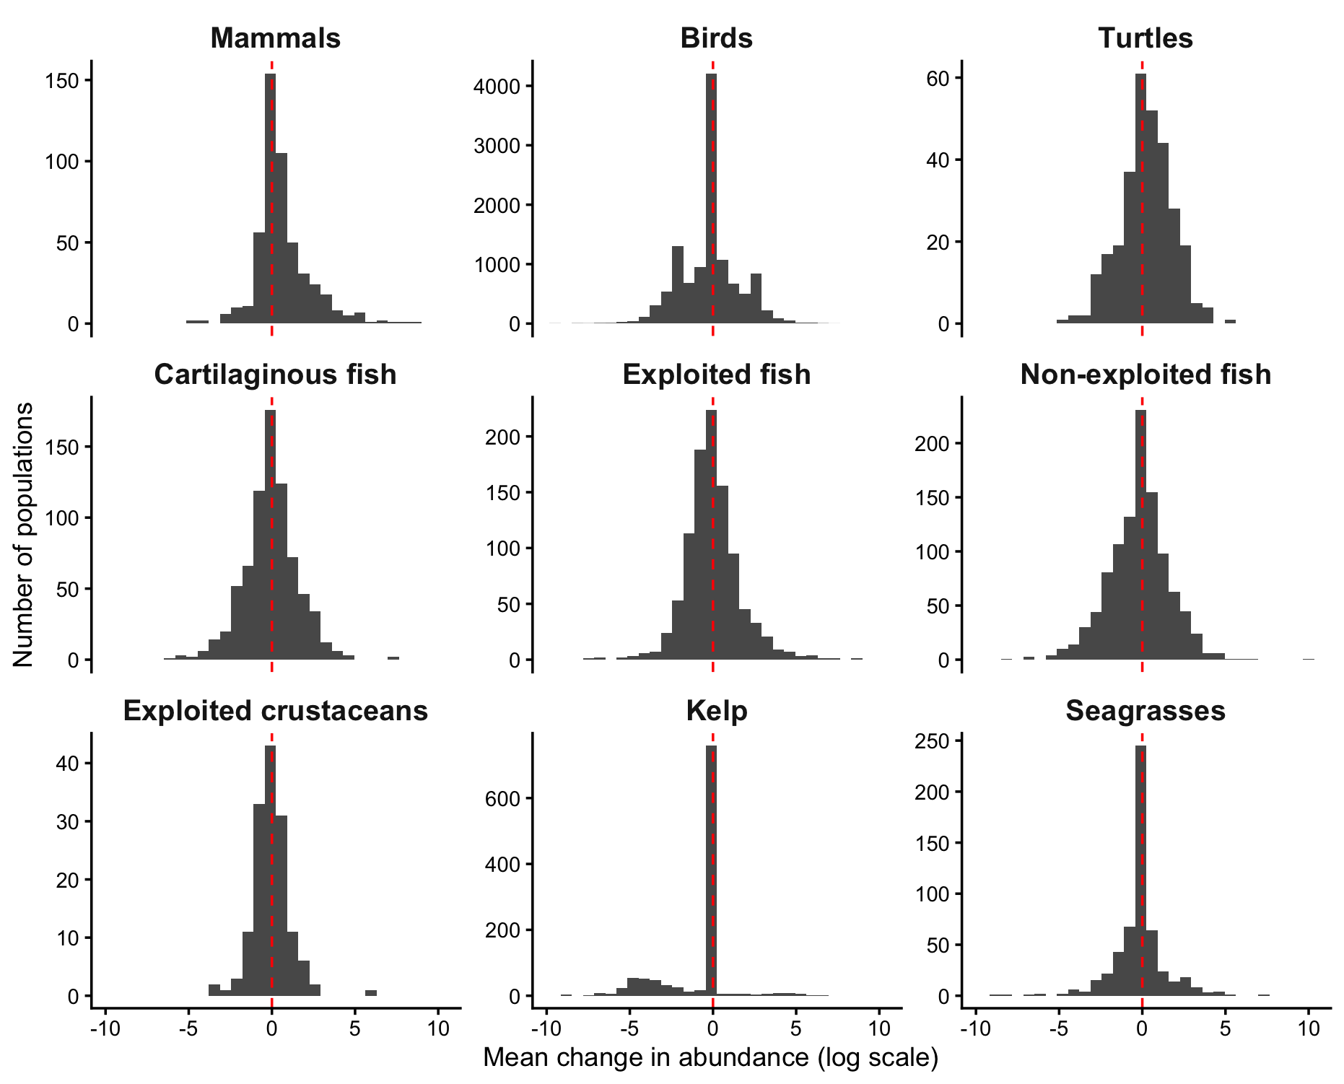

Figure S3. Distribution of mean change in abundance (in log scale) for each time series by major taxonomic group. Red vertical lines represent 0 change.
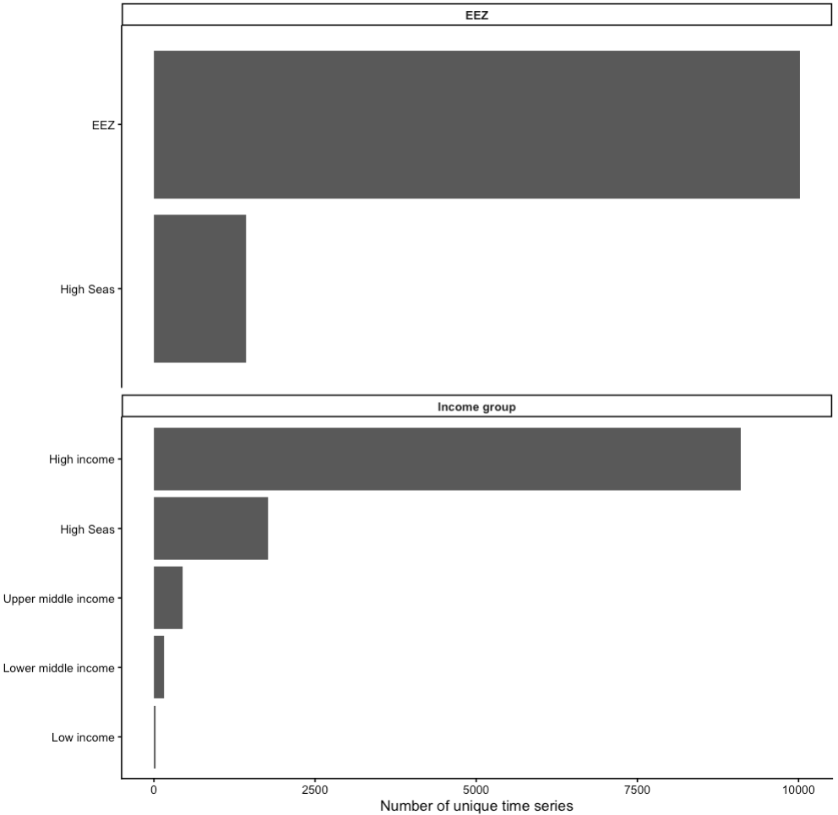

Figure S4. Number of unique sites with time series by presence in EEZ or high seas (top) and by country income classes (bottom).

References
1. Hilborn, R.Recent trends in abundance and fishing pressure of agency‐assessed small pelagic fish stocks. Fish and Fisheries 23, 1313–1331 (2022).
2. Blasco, G. D., Ferraro, D. M., Cottrell, R. S., Halpern, B. S. & Froehlich, H. E. Substantial gaps in the current fisheries data landscape. Frontiers in Marine Science 7, 612831 (2020).
3. Costello, C.Status and solutions for the world’s unassessed fisheries. Science 338, 517–520 (2012).
4. Neubauer, P., Jensen, O. P., Hutchings, J. A. & Baum, J. K. Resilience and recovery of overexploited marine populations. Science 340, 347–349 (2013).
5. Hilborn, R.Effective fisheries management instrumental in improving fish stock status. Proc. Natl. Acad. Sci. U.S.A. 117, 2218–2224 (2020).
6. Maunder, M. N. Review and evaluation of likelihood functions for composition data in stock-assessment models: Estimating the effective sample size. Fisheries Research 109, 311–319 (2011).
7. Rex, M. A. et al. Global-scale latitudinal patterns of species diversity in the deep-sea benthos. Nature 365, 636–639 (1993).
8. Hillebrand, H. Strength, slope and variability of marine latitudinal gradients. Marine Ecology Progress Series 273, 251–267 (2004).
9. Rogers, A. D. et al. Critical habitats and biodiversity: inventory, thresholds and governance. in The Blue Compendium: From Knowledge to Action for a Sustainable Ocean Economy 333–392 (Springer, 2023).
10. Rogers, A. D. Environmental change in the deep ocean. Annual Review of Environment and Resources 40, 1–38 (2015).
11. Danovaro, R. Understanding marine biodiversity patterns and drivers: The fall of Icarus. Marine Ecology e12814 (2024).
12. Boënnec, M., Dakos, V. & Devictor, V. Sources of confusion in global biodiversity trends. Oikos 2024, e10732 (2024).
13. Dornelas, M. et al. Looking back on biodiversity change: lessons for the road ahead. Phil. Trans. R. Soc. B 378, 20220199 (2023).
14. Dayton, P. K. Toward an understanding of community resilience and the potential effects of enrichments to the benthos at McMurdo Sound, Antarctica. (1972).
15. Wernberg, T. et al. Impacts of climate change on marine foundation species. Annual review of marine science 16, 247–282 (2024).
16. Bimrah, K., Dasgupta, R., Hashimoto, S., Saizen, I. & Dhyani, S. Ecosystem services of mangroves: A systematic review and synthesis of contemporary scientific literature. Sustainability 14, 12051 (2022).
17. Giglio, V. J. et al. A global systematic literature review of ecosystem services in reef environments. Environmental Management 73, 634–645 (2024).
18. Boudouresque, C. F. & Verlaque, M. Biological pollution in the Mediterranean Sea: invasive versus introduced macrophytes. Marine pollution bulletin 44, 32–38 (2002).
19. Chagaris, D. et al. An ecosystem‐based approach to evaluating impacts and management of invasive lionfish. Fisheries 42, 421–431 (2017).
20. Vercelloni, J., Caley, M. J. & Mengersen, K. Crown‐of‐thorns starfish undermine the resilience of coral populations on the Great Barrier Reef. Global Ecology and Biogeography 26, 846–853 (2017).
21. Cohen, A. N. & Carlton, J. T. Accelerating invasion rate in a highly invaded estuary. Science 279, 555–558 (1998).
22. Molnar, J. L., Gamboa, R. L., Revenga, C. & Spalding, M. D. Assessing the global threat of invasive species to marine biodiversity. Frontiers in Ecology and the Environment 6, 485–492 (2008).
23. Jambeck, J. R. et al. Plastic waste inputs from land into the ocean. Science 347, 768–771 (2015).
24. Senko, J. F. et al. Understanding individual and population-level effects of plastic pollution on marine megafauna. Endangered Species Research 43, 234–252 (2020).
25. MacLeod, M., Arp, H. P. H., Tekman, M. B. & Jahnke, A. The global threat from plastic pollution. Science 373, 61–65 (2021).
26. Jiménez-Contreras, J., Fernández-Medina, R. I. & Fernández-Araiza, M. A. Microplastics pollution in tropical lakes: water, zooplankton, and fish in Central Mexico. Environ Monit Assess 196, 813 (2024).
27. Bos, R. P., Zhao, S., Sutton, T. T. & Frank, T. M. Microplastic ingestion by deep-pelagic crustaceans and fishes. Limnology and Oceanography 68, 1595–1610 (2023).
28. Zolotova, N., Kosyreva, A., Dzhalilova, D., Fokichev, N. & Makarova, O. Harmful effects of the microplastic pollution on animal health: a literature review. PeerJ 10, e13503 (2022).
29. de Barros, M. S. F., dos Santos Calado, T. C. & de Sá Leitão Câmara de Araújo, M. Plastic ingestion lead to reduced body condition and modified diet patterns in the rocky shore crab Pachygrapsus transversus (Gibbes, 1850) (Brachyura: Grapsidae). Marine Pollution Bulletin 156, 111249 (2020).
30. Starr, M. et al. Multispecies mass mortality of marine fauna linked to a toxic dinoflagellate bloom. PLOS ONE 12, e0176299 (2017).
31. Häussermann, V. et al. Largest baleen whale mass mortality during strong El Niño event is likely related to harmful toxic algal bloom. PeerJ 5, e3123 (2017).
32. Diaz, R. J. & Rosenberg, R. Spreading Dead Zones and Consequences for Marine Ecosystems. Science 321, 926–929 (2008).
33. Banaee, M. Perspective Chapter: Exploring the Toxicity Effect of Heavy Metals on Aquatic Organisms – A Comprehensive Analysis. in Heavy Metals in the Environment - Contamination, Risk, and Remediation (IntechOpen, 2024). doi:10.5772/intechopen.1006890.
34. Garlock, T. et al. A global blue revolution: aquaculture growth across regions, species, and countries. Reviews in Fisheries Science & Aquaculture 28, 107–116 (2020).
35. Klinger, D. & Naylor, R. Searching for solutions in aquaculture: charting a sustainable course. Annual Review of Environment and Resources 37, 247–276 (2012).
36. Kraus, S. D. et al. North Atlantic right whales in crisis. Science 309, 561–562 (2005).
37. Womersley, F. C., Loveridge, A. & Sims, D. W. Four steps to curb ‘ocean roadkill’. Nature 621, 34–38 (2023).
38. Taveira-Pinto, F., Rosa-Santos, P. & Fazeres-Ferradosa, T. Marine renewable energy. Renewable Energy 150, 1160–1164 (2020).
39. Dedman, S. et al. Ecological roles and importance of sharks in the Anthropocene Ocean. Science 385, adl2362 (2024).
40. Forcada, J., Trathan, P., Reid, K. & Murphy, E. The effects of global climate variability in pup production of Antarctic fur seals. Ecology 86, 2408–2417 (2005).
41. Krumhardt, K. M., Long, M. C., Sylvester, Z. T. & Petrik, C. M. Climate drivers of Southern Ocean phytoplankton community composition and potential impacts on higher trophic levels. Frontiers in Marine Science 9, 916140 (2022).
42. Wade, P. R. et al. Killer whales and marine mammal trends in the North Pacific—A re‐examination of evidence for sequential megafauna collapse and the prey‐switching hypothesis. Marine Mammal Science 23, 766–802 (2007).
43. Richards, R. A. & Hunter, M. Northern shrimp Pandalus borealis population collapse linked to climate-driven shifts in predator distribution. PLoS One 16, e0253914 (2021).
44. McCard, M. et al. Pushing the switch: functional responses and prey switching by invasive lionfish may mediate their ecological impact. Biological invasions 23, 2019–2032 (2021).
45. Pinsky, M. L., Worm, B., Fogarty, M. J., Sarmiento, J. L. & Levin, S. A. Marine taxa track local climate velocities. Science 341, 1239–1242 (2013).
46. O’Connor, M. I. et al. Temperature control of larval dispersal and the implications for marine ecology, evolution, and conservation. Proceedings of the National Academy of Sciences 104, 1266–1271 (2007).
47. Hodapp, D. et al. Climate change disrupts core habitats of marine species. Global Change Biology 29, 3304–3317 (2023).
48. Spence, A. R. & Tingley, M. W. The challenge of novel abiotic conditions for species undergoing climate‐induced range shifts. Ecography 43, 1571–1590 (2020).
49. Rosenblad, K. C. & Sax, D. F. A new framework for investigating biotic homogenization and exploring future trajectories: Oceanic island plant and bird assemblages as a case study. Ecography 40, 1040–1049 (2017).
50. McLean, M. et al. Fish communities diverge in species but converge in traits over three decades of warming. Global Change Biology 25, 3972–3984 (2019).
51. Berkeley, S. A., Chapman, C. & Sogard, S. M. Maternal Age as a Determinant of Larval Growth and Survival in a Marine Fish, Sebastes Melanops. Ecology 85, 1258–1264 (2004).
52. Hixon, M. A., Johnson, D. W. & Sogard, S. M. BOFFFFs: on the importance of conserving old-growth age structure in fishery populations. ICES J Mar Sci 71, 2171–2185 (2014).
53. McCauley, D. J. et al. Marine defaunation: Animal loss in the global ocean. Science 347, 1255641 (2015).
54. García Molinos, J., Burrows, M. & Poloczanska, E. S. Ocean currents modify the coupling between climate change and biogeographical shifts. Scientific reports 7, 1332 (2017).
55. Pappalardo, P., Pringle, J. M., Wares, J. P. & Byers, J. E. The location, strength, and mechanisms behind marine biogeographic boundaries of the east coast of North America. Ecography 38, 722–731 (2015).
56. Costello, M. J. et al. A census of marine biodiversity knowledge, resources, and future challenges. PloS one 5, e12110 (2010).
57. The State of World Fisheries and Aquaculture 2022. (FAO, 2022). doi:10.4060/cc0461en.
58. Berkes, F. et al. Globalization, Roving Bandits, and Marine Resources. Science 311, 1557–1558 (2006).
59. Bell, J. D., Watson, R. A. & Ye, Y. Global fishing capacity and fishing effort from 1950 to 2012. Fish and Fisheries 18, 489–505 (2017).
60. Rousseau, Y., Watson, R. A., Blanchard, J. L. & Fulton, E. A. Evolution of global marine fishing fleets and the response of fished resources. Proceedings of the National Academy of Sciences 116, 12238–12243 (2019).
61. Holm, P. World War II and the “Great Acceleration” of North Atlantic Fisheries. Global Environment 5, 66–91 (2012).
62. Robins, C. M., Wang, Y.-G. & Die, D. The impact of global positioning systems and plotters on fishing power in the northern prawn fishery, Australia. Can. J. Fish. Aquat. Sci. 55, 1645–1651 (1998).
63. Anticamara, J. A., Watson, R., Gelchu, A. & Pauly, D. Global fishing effort (1950–2010): Trends, gaps, and implications. Fisheries Research 107, 131–136 (2011).
64. He, P. Innovation, impacts, challenges and future of synthetic materials in capture fisheries. ICES J Mar Sci 83, fsag081 (2026).
65. The State of World Fisheries and Aquaculture 2026. (FAO, 2026). doi:10.4060/cd8357en.
66. Worm, B. et al. Rebuilding Global Fisheries. Science 325, 578–585 (2009).
67. Harkonen, T. et al. Collapse of a Marine Mammal Species Driven by Human Impacts. PLOS ONE 7, e43130 (2012).
68. Wilen, J. E. Common Property Resources and the Dynamics of Overexploitation: The Case of the North Pacific Fur Seal. Marine Resource Economics 33, 217–243 (2018).
69. Estes, J. A. Chapter 2 - Natural History, Ecology, and the Conservation and Management of Sea Otters. in Sea Otter Conservation (eds Larson, S. E., Bodkin, J. L. & VanBlaricom, G. R.) 19–41 (Academic Press, Boston, 2015). doi:10.1016/B978-0-12-801402-8.00002-0.
70. Loshbaugh, S. Sea Otters and the Maritime Fur Trade. in Ethology and Behavioral Ecology of Sea Otters and Polar Bears (eds Davis, R. W. & Pagano, A. M.) 173–204 (Springer International Publishing, Cham, 2021). doi:10.1007/978-3-030-66796-2_10.
71. Whales, Whaling, and Ocean Ecosystems. (University of California Press, Berkeley Los Angeles London, 16). doi:10.1525/california/9780520248847.001.0001.
72. Tulloch, V. J. D., Plagányi, É. E., Matear, R., Brown, C. J. & Richardson, A. J. Ecosystem modelling to quantify the impact of historical whaling on Southern Hemisphere baleen whales. Fish and Fisheries 19, 117–137 (2018).
73. Hilborn, R., Punt, A. E. & Orensanz, J. Beyond band-aids in fisheries management: fixing world fisheries. Bulletin of Marine Science 74, 493–507 (2004).
74. Worm, B. & Branch, T. A. The future of fish. Trends in Ecology & Evolution 27, 594–599 (2012).
75. Melnychuk, M. C. et al. Identifying management actions that promote sustainable fisheries. Nat Sustain 4, 440–449 (2021).
76. Petrossian, G. A. Preventing illegal, unreported and unregulated (IUU) fishing: A situational approach. Biological Conservation 189, 39–48 (2015).
77. Polacheck, T. Assessment of IUU fishing for Southern Bluefin Tuna. Marine Policy 36, 1150–1165 (2012).
78. McCluskey, S. M. & Lewison, R. L. Quantifying fishing effort: a synthesis of current methods and their applications. Fish and Fisheries 9, 188–200 (2008).
79. Reynolds, J. D., Jennings, S. & Dulvy, N. K. Life histories of fishes and population responses to exploitation. CONSERVATION BIOLOGY SERIES-CAMBRIDGE- 147–168 (2001).
80. Dulvy, N. K. et al. Bending back the curve of shark and ray biodiversity loss. Nature Reviews Biodiversity 1–24 (2026).
81. Dulvy, N. K. et al. Overfishing drives over one-third of all sharks and rays toward a global extinction crisis. Current Biology 31, 4773–4787 (2021).
82. Pacoureau, N. et al. Half a century of global decline in oceanic sharks and rays. Nature 589, 567–571 (2021).
83. Alfaro-Shigueto, J. et al. Where small can have a large impact: structure and characterization of small-scale fisheries in Peru. Fisheries Research 106, 8–17 (2010).
84. Pons, M. et al. Effects of biological, economic and management factors on tuna and billfish stock status. Fish and Fisheries 18, 1–21 (2017).
85. Juan-Jordá, M. J., Mosqueira, I., Cooper, A. B., Freire, J. & Dulvy, N. K. Global population trajectories of tunas and their relatives. Proceedings of the National Academy of Sciences 108, 20650–20655 (2011).
86. Hilborn, R. et al. Global status of groundfish stocks. Fish and Fisheries 22, 911–928 (2021).
87. Sparholt, H. et al. Estimating F msy from an ensemble of data sources to account for density dependence in Northeast Atlantic fish stocks. ICES Journal of Marine Science 78, 55–69 (2021).
88. Conover, D. O. & Munch, S. B. Sustaining fisheries yields over evolutionary time scales. science 297, 94–96 (2002).
89. Garcia, S. M. et al. Reconsidering the consequences of selective fisheries. Science 335, 1045–1047 (2012).
90. Law, R., Plank, M. J. & Kolding, J. Balanced exploitation and coexistence of interacting, size‐structured, fish species. Fish and Fisheries 17, 281–302 (2016).
91. Law, R., Kolding, J. & Plank, M. J. Squaring the circle: reconciling fishing and conservation of aquatic ecosystems. Fish and Fisheries 16, 160–174 (2015).
92. Jacobsen, N. S., Gislason, H. & Andersen, K. H. The consequences of balanced harvesting of fish communities. Proceedings of the Royal Society B: Biological Sciences 281, (2014).
93. Hsieh, C., Yamauchi, A., Nakazawa, T. & Wang, W.-F. Fishing effects on age and spatial structures undermine population stability of fishes. Aquatic Sciences 72, 165–178 (2010).
94. Sheldon, R., Prakash, A. & Sutcliffe Jr, Wh. The size distribution of particles in the ocean. Limnology and oceanography 17, 327–340 (1972).
95. Hatton, I. A., Heneghan, R. F., Bar-On, Y. M. & Galbraith, E. D. The global ocean size spectrum from bacteria to whales. Science Advances 7, eabh3732 (2021).
96. Kolding, J., Jacobsen, N. S., Andersen, K. H. & van Zwieten, P. A. Maximizing fisheries yields while maintaining community structure. Canadian Journal of Fisheries and Aquatic Sciences 73, 644–655 (2016).
97. Pauly, D., Christensen, V., Dalsgaard, J., Froese, R. & Torres Jr, F. Fishing down marine food webs. Science 279, 860–863 (1998).
98. Baum, J. K. & Worm, B. Cascading top-down effects of changing oceanic predator abundances. Journal of Animal Ecology 78, 699–714 (2009).
99. Shanafelt, D. W. & Loreau, M. Stability trophic cascades in food chains. R Soc Open Sci. 5, 180995 (2018).
100. Etnier, M. A. Reevaluating evidence of density-dependent growth in northern fur seals (Callorhinus ursinus) based on measurements of archived skeletal specimens. Canadian Journal of Fisheries and Aquatic Sciences 61, 1616–1626 (2004).
101. Sethi, S. A., Branch, T. A. & Watson, R. Global fishery development patterns are driven by profit but not trophic level. Proceedings of the National Academy of Sciences 107, 12163–12167 (2010).
102. Watson, R. A. A database of global marine commercial, small-scale, illegal and unreported fisheries catch 1950–2014. Scientific Data 4, 1–9 (2017).
103. Frank, K. T., Petrie, B., Choi, J. S. & Leggett, W. C. Trophic cascades in a formerly cod-dominated ecosystem. Science 308, 1621–1623 (2005).
104. Gaines, S. D. et al. Improved fisheries management could offset many negative effects of climate change. Science advances 4, eaao1378 (2018).
105. Yin, J. et al. Potential impacts of ocean warming on the trophic control of a threatened marine ecosystem. Progress in Oceanography 211, 102976 (2023).
106. Golden, C. D. et al. Nutrition: Fall in fish catch threatens human health. Nature 534, 317–320 (2016).
107. Judah, A. B. et al. Deep-sea mining risks for sharks, rays, and chimaeras. Current Biology 35, 5353–5362 (2025).
108. Bowlby, H. D., Hammerschlag, N., Irion, D. T. & Gennari, E. How continuing mortality affects recovery potential for prohibited sharks: the case of white sharks in South Africa. Frontiers in Conservation Science 3, 988693 (2022).
109. Christensen, V. et al. A century of fish biomass decline in the ocean. Marine ecology progress series 512, 155–166 (2014).
110. Kolding, J., Bundy, A., van Zwieten, P. A. & Plank, M. J. Fisheries, the inverted food pyramid. ICES Journal of Marine Science 73, 1697–1713 (2016).
111. Hilborn, R. et al. Global status of groundfish stocks. Fish and Fisheries 22, 911–928 (2021).
112. Pons, M. et al. Effects of biological, economic and management factors on tuna and billfish stock status. Fish and Fisheries 18, 1–21 (2017).
113. Juan-Jordá, M. J., Mosqueira, I., Cooper, A. B., Freire, J. & Dulvy, N. K. Global population trajectories of tunas and their relatives. Proceedings of the National Academy of Sciences 108, 20650–20655 (2011).
114. Duggins, D. O., Simenstad, C. & Estes, J. A. Magnification of secondary production by kelp detritus in coastal marine ecosystems. Science 245, 170–173 (1989).
115. Steneck, R. S., Vavrinec, J. & Leland, A. V. Accelerating trophic-level dysfunction in kelp forest ecosystems of the western North Atlantic. Ecosystems 7, 323–332 (2004).
116. Worm, B. & Myers, R. A. Meta‐analysis of cod–shrimp interactions reveals top‐down control in oceanic food webs. Ecology 84, 162–173 (2003).
117. Myers, R. A., Baum, J. K., Shepherd, T. D., Powers, S. P. & Peterson, C. H. Cascading effects of the loss of apex predatory sharks from a coastal ocean. Science 315, 1846–1850 (2007).
118. Bell, J. J., Bennett, H. M., Rovellini, A. & Webster, N. S. Sponges to be winners under near-future climate scenarios. Bioscience 68, 955–968 (2018).
119. Gregg, W. W., Rousseaux, C. S. & Franz, B. A. Global trends in ocean phytoplankton: a new assessment using revised ocean colour data. Remote Sensing Letters 8, 1102–1111 (2017).
120. Gregg, W. W. & Rousseaux, C. S. Decadal trends in global pelagic ocean chlorophyll: A new assessment integrating multiple satellites, in situ data, and models. Journal of Geophysical Research: Oceans 119, 5921–5933 (2014).
121. Laufkötter, C., Vogt, M. & Gruber, N. Long-term trends in ocean plankton production and particle export between 1960–2006. Biogeosciences 10, 7373–7393 (2013).
122. Behrenfeld, M. J. & Falkowski, P. G. Photosynthetic rates derived from satellite‐based chlorophyll concentration. Limnology and oceanography 42, 1–20 (1997).
123. Purvis, A. et al. The Global Assessment Report on Biodiversity and Ecosystem Services: Chapter 2.2 Status and Trends–Nature. Zenodo (2019).
124. Johnston, N. M. et al. Status, change, and futures of zooplankton in the Southern Ocean. Frontiers in Ecology and Evolution 9, 624692 (2022).
125. Pitois, S. G. & Fox, C. J. Long-term changes in zooplankton biomass concentration and mean size over the Northwest European shelf inferred from Continuous Plankton Recorder data. ICES Journal of Marine Science 63, 785–798 (2006).
126. Gomez, F. A. et al. ENSO-induced co-variability of Salinity, Plankton Biomass and Coastal Currents in the Northern Gulf of Mexico. Sci Rep 9, 178 (2019).
127. Thompson, P. et al. Climate variability drives plankton community composition changes: the 2010–2011 El Niño to La Niña transition around Australia. Journal of Plankton Research 37, 966–984 (2015).
128. Hubert, Z. et al. Decadal changes in phytoplankton functional composition in the Eastern English Channel: possible upcoming major effects of climate change. Ocean Science 21, 679–700 (2025).
129. Shephard, S., Brophy, D. & Reid, D. G. Can bottom trawling indirectly diminish carrying capacity in a marine ecosystem? Marine Biology 157, 2375–2381 (2010).
130. Reddin, C. J., Aberhan, M., Raja, N. B. & Kocsis, Á. T. Global warming generates predictable extinctions of warm‐and cold‐water marine benthic invertebrates via thermal habitat loss. Global Change Biology 28, 5793–5807 (2022).
131. Barroso, C. X. et al. Threats and challenges for the conservation of marine molluscs in the southwestern Atlantic. Aquatic Sciences 87, 66 (2025).
132. Boavida-Portugal, J., Guilhaumon, F., Rosa, R. & Araújo, M. B. Global patterns of coastal cephalopod diversity under climate change. Frontiers in Marine Science 8, 740781 (2022).
133. Connell, S. D. Water quality and the loss of coral reefs and kelp forests: alternative states and the influence of fishing. Marine ecology. Oxford University Press, Melbourne 556–568 (2007).
134. Layton, C. et al. Habitat fragmentation causes collapse of kelp recruitment. Marine Ecology Progress Series 648, 111–123 (2020).
135. Akram, H. et al. Mangrove health: A review of functions, threats, and challenges associated with mangrove management practices. Forests 14, 1698 (2023).
136. Santos-Tovar, A. et al. Habitat fragmentation erodes taxonomic and functional diversity of waterbird communities of the South Pacific coast of Mexico. Ornithology Research 32, 124–134 (2024).
137. McCormick, M., Moore, J. & Munday, P. Influence of habitat degradation on fish replenishment. Coral reefs 29, 537–546 (2010).
138. Nelms, S. E. et al. Marine mammal conservation: over the horizon. Endangered Species Research 44, 291–325 (2021).
139. Lafferty, K. D. Parasites in marine food webs. Bulletin of Marine Science 89, 123–134 (2013).
140. Lopes, C. L., Mendes, R., Cacador, I. & Dias, J. M. Assessing salt marsh loss and degradation by combining long‐term LANDSAT imagery and numerical modelling. Land Degradation & Development 32, 4534–4545 (2021).
141. Waycott, M. et al. Accelerating loss of seagrasses across the globe threatens coastal ecosystems. Proc. Natl. Acad. Sci. U.S.A. 106, 12377–12381 (2009).
142. de Sousa Rangel, B., Hammerschlag, N. & Moreira, R. G. Urban living influences the nutritional quality of a juvenile shark species. Science of the Total Environment 776, 146025 (2021).
143. Patrício, A. R., Hawkes, L. A., Monsinjon, J. R., Godley, B. J. & Fuentes, M. M. Climate change and marine turtles: recent advances and future directions. Endangered Species Research 44, 363–395 (2021).
144. Fletcher, R. A. et al. Invasive plants negatively impact native, but not exotic, animals. Global Change Biology 25, 3694–3705 (2019).
145. Battini, N., Giachetti, C. B., Castro, K. L., Bortolus, A. & Schwindt, E. New invasive predator reduces the abundance of native prey in a cold‐temperate marine fouling community. Aquatic Conservation: Marine and Freshwater Ecosystems 31, 2842–2854 (2021).
146. Alvarez-Aguilar, A., Van Rensburg, H. & Simon, C. Impacts of alien polychaete species in marine ecosystems: a systematic review. Journal of the Marine Biological Association of the United Kingdom 102, 3–26 (2022).
147. Livore, J. P., Mendez, M. M., Van der Molen, S., Segade, M. E. & Ortiz, N. Predator-prey interaction between a native octopus and an invasive crab: Habitat and size dependent effects on consumption and behaviour. Estuarine, Coastal and Shelf Science 319, 109253 (2025).
148. Uthicke, S., Pratchett, M. S., Bronstein, O., Alvarado, J. J. & Wörheide, G. The crown-of-thorns seastar species complex: knowledge on the biology and ecology of five corallivorous Acanthaster species. Marine Biology 171, 32 (2024).
149. Grover, I. M., Tocock, M. S., Tinch, D. R. & MacDonald, D. H. Investigating public preferences for the management of native and invasive species in the context of kelp restoration. Marine Policy 132, 104680 (2021).
150. Biswas, S. R. et al. Plant invasion in mangrove forests worldwide. Forest Ecology and Management 429, 480–492 (2018).
151. Holmes, N. D. et al. Conservation of marine birds: biosecurity, control, and eradication of invasive species threats. in Conservation of Marine Birds 403–438 (Elsevier, 2023).
152. Gibble, C. M. & Harvey, J. T. Food habits of harbor seals (Phoca vitulina richardii) as an indicator of invasive species in San Francisco Bay, California. Marine Mammal Science 31, 1014–1034 (2015).
153. Rangel, B. S. et al. Unexpected prey: lemon sharks (Negaprion brevirostris) observed preying on an alien invasive freshwater fish in a remote no-take marine reserve in the Equatorial Atlantic. Environmental Biology of Fishes 108, 1599–1605 (2025).
154. Engeman, R. M. et al. Feral swine harming insular sea turtle reproduction: The origin, impacts, behavior and elimination of an invasive species. Acta Oecologica 99, 103442 (2019).
155. McIlroy, S. E. et al. Life goes on: Spatial heterogeneity promotes biodiversity in an urbanized coastal marine ecosystem. Global Change Biology 30, e17248 (2024).
156. Elizabeth Alter, S., Tariq, L., Creed, J. K. & Megafu, E. Evolutionary responses of marine organisms to urbanized seascapes. Evolutionary Applications 14, 210–232 (2021).
157. Ben-Haddad, M., Hajji, S., Abelouah, M. R. & Ait Alla, A. Urbanization Compromises the Sustainability of Coastal Ecosystems: Insights from the Reproductive Traits of the Bioindicator Clam Donax trunculus. Sustainability 17, 6622 (2025).
158. Heery, E. C., Olsen, A. Y., Feist, B. E. & Sebens, K. P. Urbanization-related distribution patterns and habitat-use by the marine mesopredator, giant Pacific octopus (Enteroctopus dofleini). Urban Ecosystems 21, 707–719 (2018).
159. Rosenberg, Y. et al. Urbanization comprehensively impairs biological rhythms in coral holobionts. Global change biology 28, 3349–3364 (2022).
160. Heery, E., Dethier, M., Feist, B., Sebens, K. & Duffy, J. E. A new tool for quantifying urbanization gradients across seascapes predicts habitat-forming macroalgal distribution patterns in the Salish Sea. Marine Ecology Progress Series 776, 1–15 (2026).
161. Graells, G., Celis-Diez, J. L., Corcoran, D. & Gelcich, S. Bird communities in coastal areas. effects of anthropogenic influences and distance from the coast. Frontiers in Ecology and Evolution 10, 807280 (2022).
162. Karachaliou, E., Schmidt, C., de Greef, E., Docker, M. F. & Garroway, C. J. Urbanisation Is Associated With Reduced Genetic Diversity in Marine Fish Populations. Molecular Ecology 34, e17711 (2025).
163. Shah Esmaeili, Y., Checon, H. H., Corte, G. N. & Turra, A. Parasitism by isopods in sandy beach fish assemblages: role of urbanization and environmental characteristics. Hydrobiologia 848, 4885–4901 (2021).
164. Lowe, M. R. & Peterson, M. S. Effects of coastal urbanization on salt marsh faunal assemblages in the northern Gulf of Mexico. Marine and Coastal Fisheries 6, 89–107 (2014).
165. Akoumianaki, I., Papaspyrou, S., Kormas, K. A. & Nicolaidou, A. Environmental variation and macrofauna response in a coastal area influenced by land runoff. Estuarine, Coastal and Shelf Science 132, 34–44 (2013).
166. Dinh, K. V. et al. Interactive effects of warming and pollutants on marine and freshwater invertebrates. Current Pollution Reports 8, 341–359 (2022).
167. Thompson, C. et al. Collapse of scallop Nodipecten nodosus production in the tropical Southeast Brazil as a possible consequence of global warming and water pollution. Science of The Total Environment 904, 166873 (2023).
168. Raimundo, J. et al. Abnormal mortality of octopus after a storm water event: Accumulated lead and lead isotopes as fingerprints. Science of The Total Environment 581, 289–296 (2017).
169. Bunting, P. et al. Global Mangrove Extent Change 1996–2020: Global Mangrove Watch Version 3.0. Remote Sensing 14, 3657 (2022).
170. Møller, A. P., Flensted-Jensen, E., Laursen, K. & Mardal, W. Fertilizer leakage to the marine environment, ecosystem effects and population trends of waterbirds in Denmark. Ecosystems 18, 30–44 (2015).
171. Fabricius, K. E. Effects of terrestrial runoff on the ecology of corals and coral reefs: review and synthesis. Marine pollution bulletin 50, 125–146 (2005).
172. Bridge, C., Methion, S. & Díaz López, B. The impact of anthropogenic pollutants on the distribution of a marine top predator within a coastal estuarine system. Environmental Monitoring and Assessment 195, 898 (2023).
173. Grabner, D., Rothe, L. E. & Sures, B. Parasites and pollutants: effects of multiple stressors on aquatic organisms. Environmental Toxicology and Chemistry 42, 1946–1959 (2023).
174. Hanley, T. C., Bowen, J. L., Kearns, P. J. & Hughes, A. R. Short‐and long‐term effects of nutrient enrichment on salt marsh plant production and microbial community structure. Journal of Ecology 109, 3779–3793 (2021).
175. Consales, G. & Marsili, L. Assessment of the conservation status of Chondrichthyans: Underestimation of the pollution threat. The European Zoological Journal 88, 165–180 (2021).
176. Van Houtan, K. S., Hargrove, S. K. & Balazs, G. H. Land use, macroalgae, and a tumor-forming disease in marine turtles. PLoS One 5, e12900 (2010).
177. Qu, F. et al. Polychaete annelid (segmented worms) abundance and species composition in the proximity (6–9 km) of the Deep Water Horizon (DWH) Oil Spill in the Deep Gulf of Mexico. Deep Sea Research Part II: Topical Studies in Oceanography 129, 130–136 (2016).
178. Blackburn, M., Mazzacano, C., Fallon, C. & Black, S. H. A review of the impacts of oil spills on marine invertebrates. The Xerces Society for Invertebrate Conservation, Portland, OR 152, (2014).
179. Durier, G. et al. Sensitivity to oil dispersants: Effects on the valve movements of the blue mussel Mytilus edulis and the giant scallop Placopecten magellanicus, in sub-arctic conditions. Aquatic toxicology 234, 105797 (2021).
180. Elumalai, P. et al. Impact of petroleum hydrocarbon and heavy metal pollution on coral reefs and mangroves: a review. Environmental Chemistry Letters 22, 1413–1435 (2024).
181. Dean, T. A., Bodkin, J. L., Jewett, S. C., Monson, D. H. & Jung, D. Changes in sea urchins and kelp following a reduction in sea otter density as a result of the Exxon Valdez oil spill. Marine Ecology Progress Series 199, 281–291 (2000).
182. Osborne, O. E., Willie, M. M. & O’Hara, P. D. The effects of oil spill dispersant use on marine birds: a review of scientific literature and identification of information gaps. Environmental Reviews 31, 243–255 (2022).
183. Grosell, M. & Pasparakis, C. Physiological responses of fish to oil spills. Annual review of marine science 13, 137–160 (2021).
184. Ramírez-León, M. R. et al. Semi-quantitative risk assessment of marine mammal oil exposure: A case study in the western Gulf of Mexico. Frontiers in Marine Science 10, 1034647 (2023).
185. Pérez-del-Olmo, A., Raga, J. A. & Kostadinova, A. Parasite communities in a marine fish indicate ecological recovery from the impacts of the Prestige oil-spill 12–13 years after the disaster. Science of the Total Environment 847, 157354 (2022).
186. Silliman, B. R. et al. Degradation and resilience in Louisiana salt marshes after the BP–Deepwater Horizon oil spill. Proceedings of the National Academy of Sciences 109, 11234–11239 (2012).
187. Lima, M. C. S., Silva, J. & Magalhães, K. M. Oil spill effects on seagrass ecosystems: a systematic review. Hydrobiologia 852, 3171–3190 (2025).
188. Wallace, B. P. et al. Oil spills and sea turtles: documented effects and considerations for response and assessment efforts. Endangered Species Research 41, 17–37 (2020).
189. Brander, S. et al. Microplastic and nanoplastic exposure and toxicity across marine taxa. in Plastics in the Sea 161–276 (Elsevier, 2025).
190. de Barros, M. S. F. & dos Santos Calado, T. C. Plastic ingestion lead to reduced body condition and modified diet patterns in the rocky shore crab Pachygrapsus transversus (Gibbes, 1850)(Brachyura: Grapsidae). Marine Pollution Bulletin 156, 111249 (2020).
191. Pedà, C. et al. Microplastic occurrence in the digestive system and health status assessment in a commercially important cephalopod species, Sepia officinalis from the Gulf of Patti (southern Tyrrhenian Sea). Marine Pollution Bulletin 214, 117780 (2025).
192. Litchfield, S. G., Schulz, K. G. & Kelaher, B. P. The influence of plastic pollution and ocean change on detrital decomposition. Marine Pollution Bulletin 158, 111354 (2020).
193. Walther, B. A. & Bergmann, M. Plastic pollution of four understudied marine ecosystems: a review of mangroves, seagrass meadows, the Arctic Ocean and the deep seafloor. Emerging Topics in Life Sciences 6, 371–387 (2022).
194. Clark, B. L. et al. Global assessment of marine plastic exposure risk for oceanic birds. Nature communications 14, 3665 (2023).
195. Zhang, E. et al. Association of zoonotic protozoan parasites with microplastics in seawater and implications for human and wildlife health. Scientific reports 12, 6532 (2022).
196. Bappy, M. M. M. et al. Distribution and retention efficiency of micro-and mesoplastics and heavy metals in mangrove, saltmarsh and cordgrass habitats along a subtropical coast. Environmental Pollution 370, 125908 (2025).
197. Douglas, J., Niner, H. & Garrard, S. Impacts of marine plastic pollution on seagrass meadows and ecosystem services in Southeast Asia. Journal of Marine Science and Engineering 12, 2314 (2024).
198. Nelms, S. E. et al. Plastic and marine turtles: a review and call for research. ICES Journal of Marine Science 73, 165–181 (2016).
199. Hale, R., Calosi, P., McNeill, L., Mieszkowska, N. & Widdicombe, S. Predicted levels of future ocean acidification and temperature rise could alter community structure and biodiversity in marine benthic communities. Oikos 120, 661–674 (2011).
200. Shi, Y. & Li, Y. Impacts of ocean acidification on physiology and ecology of marine invertebrates: a comprehensive review. Aquatic Ecology 58, 207–226 (2024).
201. Kruft Welton, R. A., Hoppit, G., Schmidt, D. N., Witts, J. D. & Moon, B. C. Reviews and syntheses: The clam before the storm–a meta-analysis showing the effect of combined climate change stressors on bivalves. Biogeosciences 21, 223–239 (2024).
202. Borges, F. O., Sampaio, E., Santos, C. P. & Rosa, R. Climate-change impacts on cephalopods: a meta-analysis. Integrative and Comparative Biology 63, 1240–1265 (2023).
203. Cornwall, C. E. et al. Global declines in coral reef calcium carbonate production under ocean acidification and warming. Proceedings of the National Academy of Sciences 118, e2015265118 (2021).
204. Smale, D. A., Burrows, M. T., Moore, P., O’Connor, N. & Hawkins, S. J. Threats and knowledge gaps for ecosystem services provided by kelp forests: a northeast Atlantic perspective. Ecology and evolution 3, 4016–4038 (2013).
205. Busch, D. S., Harvey, C. J. & McElhany, P. Potential impacts of ocean acidification on the Puget Sound food web. ICES Journal of Marine Science 70, 823–833 (2013).
206. Esbaugh, A. J. Physiological implications of ocean acidification for marine fish: emerging patterns and new insights. Journal of Comparative Physiology B 188, 1–13 (2018).
207. Schumann, N., Gales, N. J., Harcourt, R. G. & Arnould, J. P. Impacts of climate change on Australian marine mammals. Australian Journal of Zoology 61, 146–159 (2013).
208. Marcogliese, D. J. The impact of climate change on the parasites and infectious diseases of aquatic animals. Rev Sci Tech 27, 467–484 (2008).
209. Hughes, A. L., Wilson, A. M. & Morris, J. T. Hydrologic variability in a salt marsh: Assessing the links between drought and acute marsh dieback. Estuarine, Coastal and Shelf Science 111, 95–106 (2012).
210. Garrard, S. L. & Beaumont, N. J. The effect of ocean acidification on carbon storage and sequestration in seagrass beds; a global and UK context. Marine Pollution Bulletin 86, 138–146 (2014).
211. Santos, C. P. et al. Elasmobranch responses to experimental warming, acidification, and oxygen loss—A meta-analysis. Frontiers in Marine Science 8, 735377 (2021).
212. Lang, B. J. et al. Impacts of ocean warming on echinoderms: A meta‐analysis. Ecology and Evolution 13, e10307 (2023).
213. Masanja, F. et al. Impacts of marine heat extremes on bivalves. Frontiers in Marine Science 10, 1159261 (2023).
214. Goreau, T. J. & Hayes, R. L. 2023 Record marine heat waves: Coral reef bleaching HotSpot maps reveal global sea surface temperature extremes, coral mortality, and ocean circulation changes. Oxford Open Climate Change 4, kgae005 (2024).
215. Saintilan, N., Wilson, N. C., Rogers, K., Rajkaran, A. & Krauss, K. W. Mangrove expansion and salt marsh decline at mangrove poleward limits. Global change biology 20, 147–157 (2014).
216. Jones, T. et al. Marine bird mass mortality events as an indicator of the impacts of ocean warming. Marine Ecology Progress Series 737, 161–181 (2024).
217. Dahms, C. & Killen, S. S. Temperature change effects on marine fish range shifts: A meta‐analysis of ecological and methodological predictors. Global Change Biology 29, 4459–4479 (2023).
218. Orgeret, F. et al. Climate change impacts on seabirds and marine mammals: The importance of study duration, thermal tolerance and generation time. Ecology Letters 25, 218–239 (2022).
219. Nguyen, H. M., Ralph, P. J., Marín‐Guirao, L., Pernice, M. & Procaccini, G. Seagrasses in an era of ocean warming: a review. Biological reviews 96, 2009–2030 (2021).
220. Taghon, G. L., Ramey, P. A., Fuller, C. M., Petrecca, R. F. & Grassle, J. P. Benthic community structure and sediment properties in Barnegat Bay, New Jersey, before and after Hurricane Sandy. Estuaries and Coasts 40, 160–172 (2017).
221. Corte, G. N. et al. Storm effects on intertidal invertebrates: increased beta diversity of few individuals and species. PeerJ 5, e3360 (2017).
222. Wiesebron, L. et al. Contrasting strategies to cope with storm‐induced erosion events: a flume study comparing a native vs. introduced bivalve. Limnology and Oceanography 67, 2572–2585 (2022).
223. Cheal, A. J., MacNeil, M. A., Emslie, M. J. & Sweatman, H. The threat to coral reefs from more intense cyclones under climate change. Global change biology 23, 1511–1524 (2017).
224. Peereman, J., Hogan, J. A. & Lin, T. Disturbance frequency, intensity and forest structure modulate cyclone‐induced changes in mangrove forest canopy cover. Global Ecology and Biogeography 31, 37–50 (2022).
225. Laurenson, K. et al. Long‐term multi‐species demographic studies reveal divergent negative impacts of winter storms on seabird survival. Journal of Animal Ecology 94, 139–153 (2025).
226. Cooke, S. J. et al. Consequences of “natural” disasters on aquatic life and habitats. Environmental reviews 31, 122–140 (2022).
227. Saville, K. et al. Vulnerability of Grey Seal Pups (Halichoerus grypus) to Storm Disturbances in the Context of Climate Change: A British Isles Case Study. in vol. 6 19 (MDPI, 2025).
228. Feehan, C. J., Scheibling, R. E., Brown, M. S. & Thompson, K. R. Marine epizootics linked to storms: Mechanisms of pathogen introduction and persistence inferred from coupled physical and biological time‐series. Limnology and Oceanography 61, 316–329 (2016).
229. Pannozzo, N., Leonardi, N., Carnacina, I. & Smedley, R. Salt marsh resilience to sea-level rise and increased storm intensity. Geomorphology 389, 107825 (2021).
230. Preen, A. & Marsh, H. Response of dugongs to large-scale loss of seagrass from Hervey Bay, Queensland Australia. Wildlife Research 22, 507–519 (1995).
231. Gutowsky, L. et al. Large sharks exhibit varying behavioral responses to major hurricanes. Estuarine, Coastal and Shelf Science 256, 107373 (2021).
232. Singer, A. et al. Long-term response of coastal macrofauna communities to de-eutrophication and sea level rise mediated habitat changes (1980s versus 2018). Frontiers in Marine Science 9, 963325 (2023).
233. Hallam, A. The case for sea-level change as a dominant causal factor in mass extinction of marine invertebrates. Philosophical Transactions of the Royal Society of London. B, Biological Sciences 325, 437–455 (1989).
234. Isdell, R. E., Bilkovic, D. M. & Hershner, C. Large projected population loss of a salt marsh bivalve (Geukensia demissa) from sea level rise. Wetlands 40, 1729–1738 (2020).
235. Xavier, J. C. et al. A review on the biodiversity, distribution and trophic role of cephalopods in the Arctic and Antarctic marine ecosystems under a changing ocean. Marine biology 165, 93 (2018).
236. Perry, C. T. et al. Loss of coral reef growth capacity to track future increases in sea level. Nature 558, 396–400 (2018).
237. Valero, M. et al. Using genetic tools for sustainable management of kelps: a literature review and the example of Laminaria digitata. CBM-Cahiers de Biologie Marine 52, 467 (2011).
238. Godoy, M. D. & Lacerda, L. D. de. Mangroves response to climate change: a review of recent findings on mangrove extension and distribution. Anais da Academia Brasileira de Ciências 87, 651–667 (2015).
239. Galbraith, H. et al. Global climate change and sea level rise: potential losses of intertidal habitat for shorebirds. Waterbirds 25, 173–183 (2002).
240. Johannessen, O. M. & Miles, M. W. Critical vulnerabilities of marine and sea ice–based ecosystems in the high Arctic. Regional Environmental Change 11, 239–248 (2011).
241. Pagano, A. M. & Williams, T. M. Physiological consequences of Arctic sea ice loss on large marine carnivores: unique responses by polar bears and narwhals. Journal of Experimental Biology 224, jeb228049 (2021).
242. Capistrant-Fossa, K. A. & Dunton, K. H. Rapid sea level rise causes loss of seagrass meadows. Communications Earth & Environment 5, 87 (2024).
243. Niella, Y. et al. Reliance of young sharks on threatened estuarine habitats for nutrition implies susceptibility to climate change. Estuarine, Coastal and Shelf Science 268, 107790 (2022).
244. Qu, F., Nunnally, C. & Rowe, G. T. Polychaete annelid biomass size spectra: the effects of hypoxia stress. Journal of Marine Sciences 2015, 983521 (2015).
245. Craig, J. K. et al. Ecological effects of hypoxia on fish, sea turtles, and marine mammals in the northwestern Gulf of Mexico. Coastal hypoxia: consequences for living resources and ecosystems 58, 269–291 (2001).
246. Seibel, B. A. Cephalopod susceptibility to asphyxiation via ocean incalescence, deoxygenation, and acidification. Physiology 31, 418–429 (2016).
247. Hughes, D. J. et al. Coral reef survival under accelerating ocean deoxygenation. Nature Climate Change 10, 296–307 (2020).
248. Ng, C. A. & Micheli, F. Short-term effects of hypoxia are more important than effects of ocean acidification on grazing interactions with juvenile giant kelp (Macrocystis pyrifera). Scientific reports 10, 5403 (2020).
249. Meera, S. P., Bhattacharyya, M. & Kumar, A. Dynamics of mangrove functional traits under osmotic and oxidative stresses. Plant Growth Regulation 101, 285–306 (2023).
250. Clark, A., Ellis, W. T., Rodriguez, A. R. & Baker, R. Dissolved Oxygen May Limit the Suitability of Salt Marsh as Nekton Habitat. Estuaries and Coasts 48, 1–8 (2025).
251. Tu, T.-H., Lin, E.-J., Hung, C.-C., Chou, W.-C. & Shih, Y.-Y. The dissolved oxygen variation in seagrasses is influenced by DOC excretion and its associated microbes. Estuarine, Coastal and Shelf Science 313, 109080 (2025).
252. Vedor, M. et al. Climate-driven deoxygenation elevates fishing vulnerability for the ocean’s widest ranging shark. Elife 10, e62508 (2021).
253. Giangrande, A., Licciano, M., Musco, L. & Stabili, L. Shift in Sabella spallanzanii (Polychaeta, Sabellidae) spawning period in the Central Mediterranean Sea: a consequence of climate change? Mediterranean Marine Science 11, 373–379 (2010).
254. Long, W. C., Conrad, A. L., Gardner, J. L. & Foy, R. J. Red king crab larval survival and development are resilient to ocean acidification. Journal of Experimental Marine Biology and Ecology 577, 152028 (2024).
255. Meza‐Buendía, A. K. et al. Why high temperatures limit reproduction in cephalopods? The case of Octopus maya. Aquaculture Research 52, 5111–5123 (2021).
256. Padilla-Gamiño, J. L., Alma, L., Spencer, L. H., Venkataraman, Y. R. & Wessler, L. Ocean acidification does not overlook sex: review of understudied effects and implications of low pH on marine invertebrate sexual reproduction. Frontiers in Marine Science 9, 977754 (2022).
257. Friess, D. A., Adame, M. F., Adams, J. B. & Lovelock, C. E. Mangrove forests under climate change in a 2 C world. Wiley Interdisciplinary Reviews: Climate Change 13, e792 (2022).
258. Lourenço, S. et al. Short and long-term temperature variations drive recruitment variability in marine and estuarine juvenile fishes. Marine Pollution Bulletin 192, 115093 (2023).
259. Zhu, Z., Bouma, T. J., Zhu, Q., Cai, Y. & Yang, Z. Effects of waves and sediment disturbance on seed bank persistence at tidal flats. Frontiers in marine science 8, 728065 (2021).
260. Duarte, B. et al. Climate change impacts on seagrass meadows and macroalgal forests: an integrative perspective on acclimation and adaptation potential. Frontiers in Marine Science 5, 190 (2018).
261. Ripley, D. M., De Giorgio, S., Gaffney, K., Thomas, L. & Shiels, H. A. Ocean warming impairs the predator avoidance behaviour of elasmobranch embryos. Conservation Physiology 9, coab045 (2021).
262. Jessen, C., Voolstra, C. R. & Wild, C. In situ effects of simulated overfishing and eutrophication on settlement of benthic coral reef invertebrates in the Central Red Sea. PeerJ 2, e339 (2014).
263. Toso, A. et al. Overfishing and sea warming drive the collapse of Paracentrotus lividus. Scientific Reports 15, 18733 (2025).
264. Huang, S. et al. Diversity, distribution and intrinsic extinction vulnerability of exploited marine bivalves. Nature Communications 14, 4639 (2023).
265. Sabolić, I., Baltazar-Soares, M. & Štambuk, A. Incorporating evolutionary based tools in cephalopod fisheries management. Reviews in fish biology and fisheries 31, 485–503 (2021).
266. Loh, T.-L., McMurray, S. E., Henkel, T. P., Vicente, J. & Pawlik, J. R. Indirect effects of overfishing on Caribbean reefs: sponges overgrow reef-building corals. PeerJ 3, e901 (2015).
267. Friess, D. A. et al. The state of the world’s mangrove forests: past, present, and future. Annual Review of Environment and Resources 44, 89–115 (2019).
268. Votier, S. C., Sherley, R., Scales, K., Camphuysen, K. & Phillips, R. An overview of the impacts of fishing on seabirds, including identifying future research directions. ICES Journal of Marine Science 80, 2380–2392 (2023).
269. Link, J. S. Evidence of ecosystem overfishing in US large marine ecosystems. ICES Journal of Marine Science 78, 3176–3201 (2021).
270. Read, A. J. The looming crisis: interactions between marine mammals and fisheries. Journal of Mammalogy 89, 541–548 (2008).
271. Wood, C. L., Lafferty, K. D. & Micheli, F. Fishing out marine parasites? Impacts of fishing on rates of parasitism in the ocean. Ecology Letters 13, 761–775 (2010).
272. Altieri, A. H., Bertness, M. D., Coverdale, T. C., Herrmann, N. C. & Angelini, C. A trophic cascade triggers collapse of a salt‐marsh ecosystem with intensive recreational fishing. Ecology 93, 1402–1410 (2012).
273. Burgess, M. G. et al. Protecting marine mammals, turtles, and birds by rebuilding global fisheries. Science 359, 1255–1258 (2018).
274. Peters, E. C. Diseases of other invertebrate phyla: Porifera, cnidaria, ctenophora, annelida, echinodermata. in Pathobiology of marine and estuarine organisms 393–449 (CRC press, 2021).
275. Davies, C. E. Invertebrate health in marine protected areas (MPAs). Journal of Invertebrate Pathology 186, 107524 (2021).
276. Beck, M. W. et al. Oyster reefs at risk and recommendations for conservation, restoration, and management. Bioscience 61, 107–116 (2011).
277. Gestal, C., Pascual, S., Guerra, Á., Fiorito, G. & Vieites, J. M. Handbook of Pathogens and Diseases in Cephalopods. (Springer, 2019).
278. Vega Thurber, R. L. et al. Coral disease: Direct and indirect agents, mechanisms of disease, and innovations for increasing resistance and resilience. Annual Review of Marine Science 17, 227–255 (2025).
279. Zhang, Y. et al. Adverse environmental perturbations may threaten kelp farming sustainability by exacerbating Enterobacterales diseases. Environmental Science & Technology 58, 5796–5810 (2024).
280. Atkinson, P. W. & Baillie, S. R. Jumping species and seasons–the spread and impact of highly pathogenic avian influenza on seabirds and waterbirds. Bird Study 71, 289–292 (2024).
281. Kent, M. L. & Fournie, J. W. Importance of Marine Fish Diseases–An Overview. in Pathobiology of Marine and Estuarine Organisms 1–24 (CRC Press, 2021).
282. Reckendorf, A., Siebert, U., Parmentier, E. & Das, K. Chemical pollution and diseases of marine mammals. in Marine mammals: a deep dive into the world of science 63–78 (Springer International Publishing Cham, 2023).
283. Delli Compagni, E., Pardossi, A. & Pecchia, S. Fungal and Fungal-like Diseases of Halophytes in the Mediterranean Basin: A State-of-the-Art Review. Horticulturae 10, 313 (2024).
284. Eisenlord, M. E. et al. High infectivity and waterborne transmission of seagrass wasting disease. Royal Society Open Science 11, 240663 (2024).
285. Garner, M. A retrospective study of disease in elasmobranchs. Veterinary Pathology 50, 377–389 (2013).

